Table of Contents

[Tester 2](#_Toc55494695)

[List of testing: 2](#_Toc55494696)

[Test Plan: 3](#_Toc55494697)

[Test Design: 4](#_Toc55494698)

[Unit Test 4](#_Toc55494699)

[Module Test 6](#_Toc55494700)

[Usability Test 8](#_Toc55494701)

[Security testing 9](#_Toc55494702)

[Browser Compatibility testing 12](#_Toc55494703)

[Responsiveness testing 15](#_Toc55494704)

[Test Log: 18](#_Toc55494705)

# Tester

# List of testing:

|  |  |
| --- | --- |
| No. | Test Name |
| 01. | Unit test |
| 02. | Module test |
| 03. | Usability test |
| 04. | Security test |
| 05. | Browser compatibility test |
| 06. | Responsiveness test |

## Test Plan:

Test plan was developed at the very beginning of the working here the test plan is given along with the criteria and possible outcome of the test which will be performed on the system.

|  |  |  |  |
| --- | --- | --- | --- |
| Test no | Name | Criteria | Outcome |
| 01. | Unit test | About page & Contact page | All the data in both pages will be accurate. |
| 02. | Module test | Adding new course,  checking the database for adding new course. | All the step in enquiry will work perfectly. |
| 03. | Integration test | Add news | Adding new in the website works perfectly. |
| 04. | Usability test | Navigation bar,  Working footer. | All the features in the system will be working properly. |
| 05. | Security test | SQL injection;  Invalid login to the system. | All the security testing will be accurate. |
| 06. | Browser compatibility test | Google chrome, Mozilla Firefox, Internet Explorer | The system will run smoothly in all the selected browser. |
| 07. | Responsiveness test | Testing the system in different screen including desktop and mobile | The system will be responsive. |

## Test Design:

### Unit Test

|  |  |  |  |  |  |  |
| --- | --- | --- | --- | --- | --- | --- |
| No. | Test Title | Pre-Condition | Test Steps | Expected Results | Actual Results | |
| 01. | View about page | Accessible form home page and any other pages | Click on “About U of T” from the navigation bar to view the about page. | The test result was as expected. | As expected. | |
| F:\Dropbox\B.COMP\Semester 2\BCOMP-ICM\All workings\Shakil Tester\img\2020-11-03 15_09_00-Window.png | | | | | |
| F:\Dropbox\B.COMP\Semester 2\BCOMP-ICM\All workings\Shakil Tester\WEBSITE SCREENSHOT\ABOUT U OF T 1.PNG | | | | | |

|  |  |  |  |  |  |  |
| --- | --- | --- | --- | --- | --- | --- |
| No. | Test Title | Pre-Condition | Test Steps | Expected Results | Actual Results | |
| 02. | View Contact Page | Accessible form home page and any other pages | Select the “Contact” option from the bottom navigation bar to view the contact page of the university. | The test result was as expected. | As expected. | |
| F:\Dropbox\B.COMP\Semester 2\BCOMP-ICM\All workings\Shakil Tester\img\Contact 1.png | | | | | |
| F:\Dropbox\B.COMP\Semester 2\BCOMP-ICM\All workings\Shakil Tester\img\contact 2.png | | | | | |

### Module Test

|  |  |  |  |  |  |
| --- | --- | --- | --- | --- | --- |
| No. | Test Title | Pre-Condition | Test Steps | Expected Results | Actual Results |
| 01. | Adding new course | Accessible form home page and select add course | Click on “Add Courses” wand add new course form the edit option and adding new course. | The test result was as expected. | As expected. |

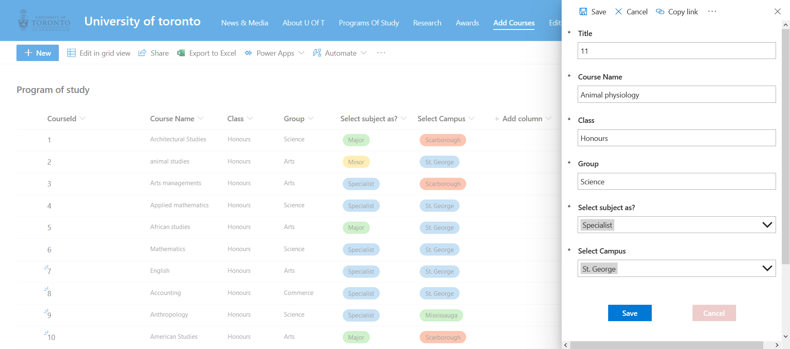

### Usability Test

|  |  |  |  |  |  |
| --- | --- | --- | --- | --- | --- |
| No. | Test Title | Pre-Condition | Test Steps | Expected Results | Actual Results |
| 01. | Navigation bar | Accessible form home page and any other pages | Click on any preferred button which will redirect the user to the selected page. | The test result was as expected. | As expected. |



|  |  |  |  |  |  |
| --- | --- | --- | --- | --- | --- |
| No. | Test Title | Pre-Condition | Test Steps | Expected Results | Actual Results |
| 02. | Working footer | Accessible form home page and any other pages | Select the preferred and worked button from the footer. | The test result was as expected. | As expected. |

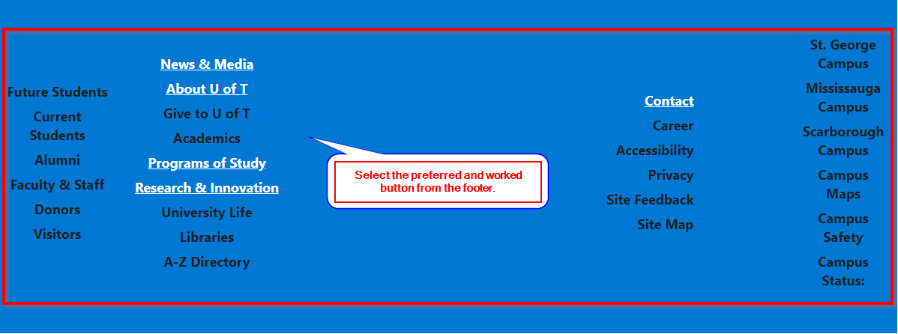

### Security testing

|  |  |  |  |  |  |
| --- | --- | --- | --- | --- | --- |
| No. | Test Title | Pre-Condition | Test Steps | Expected Results | Actual Results |
| 01. | SQL injection | The form used in the system which is connected with the database should be used to perform this action | Type in SQL command in the form | The test result was as expected. | As expected. |

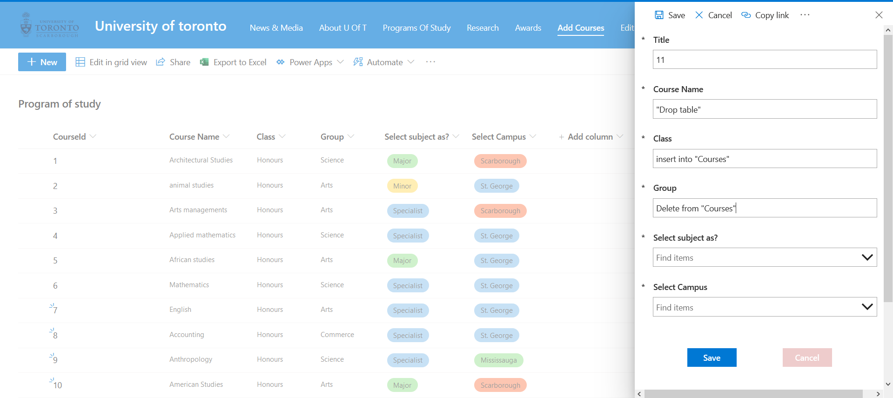

|  |  |  |  |  |  |
| --- | --- | --- | --- | --- | --- |
| No. | Test Title | Pre-Condition | Test Steps | Expected Results | Actual Results |
| 02. | Invalid password login system | The User needs to be logout from the CMS | Try inserting wrong password | The user will not be able to login to the system. | As expected. |

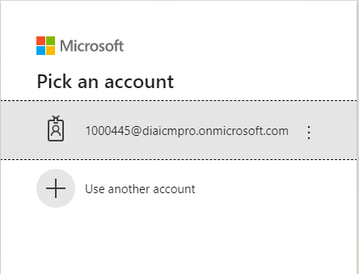

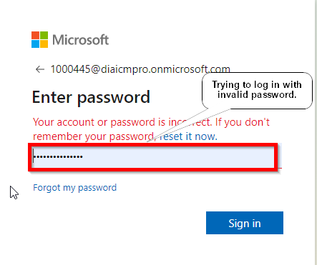

### Browser Compatibility testing

|  |  |  |  |  |  |
| --- | --- | --- | --- | --- | --- |
| No. | Test Title | Pre-Condition | Test Steps | Expected Results | Actual Results |
| 01. | Browser testing in Google Chrome. | Opening the system in the testing browser | logging in to the system | The test result was as expected. | As expected. |

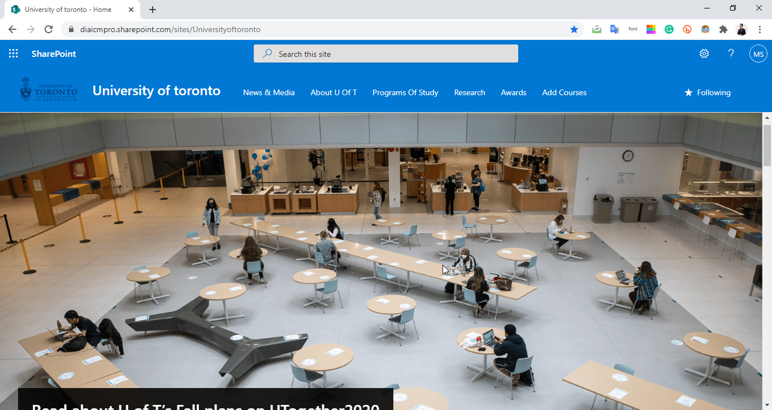

|  |  |  |  |  |  |
| --- | --- | --- | --- | --- | --- |
| No. | Test Title | Pre-Condition | Test Steps | Expected Results | Actual Results |
| 02. | Browser testing in Mozilla Firefox | Opening the system in the testing browser | logging in to the system | The test result was as expected. | As expected. |

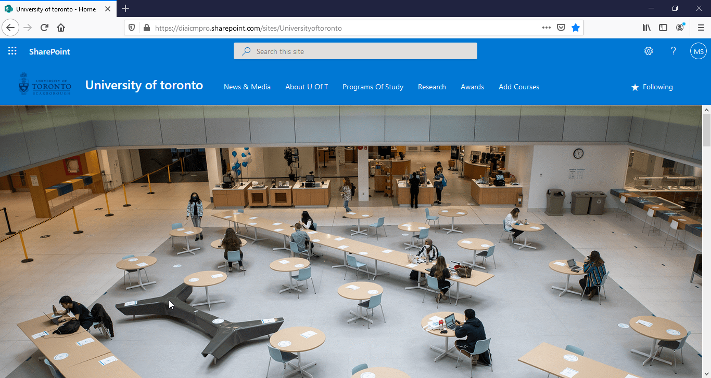

|  |  |  |  |  |  |
| --- | --- | --- | --- | --- | --- |
| No. | Test Title | Pre-Condition | Test Steps | Expected Results | Actual Results |
| 03. | Browser testing in Microsoft Edge. | Opening the system in the testing browser | logging in to the system | The test result was as expected. | As expected. |

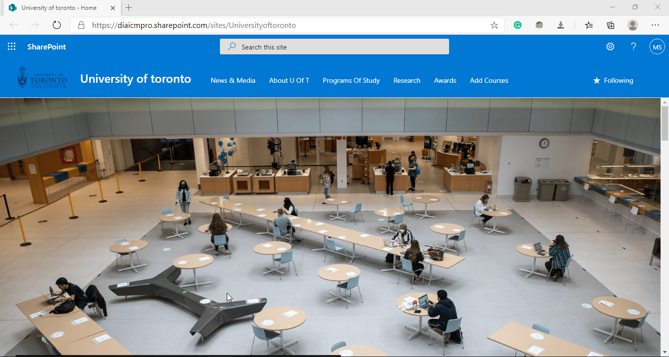

### Responsiveness testing

|  |  |  |  |  |  |
| --- | --- | --- | --- | --- | --- |
| No. | Test Title | Pre-Condition | Test Steps | Expected Results | Actual Results |
| 01. | Testing for large screen or website | Opening the system in the testing browser of a desktop pc. | logging in to the system and open the home page. | The test result was as expected. | As expected. |



|  |  |  |  |  |  |
| --- | --- | --- | --- | --- | --- |
| No. | Test Title | Pre-Condition | Test Steps | Expected Results | Actual Results |
| 01. | Testing for mobile screen. | Opening the system in the mobile view browser. | logging in to the system and open the home page. | The test result was as expected. | As expected. |



## Test Log:

|  |  |  |  |  |
| --- | --- | --- | --- | --- |
| Test no | Name | Criteria | Outcome | Result |
| 01. | Unit test | About page & Contact page | All the data in both pages will be accurate. | As Expected |
| 02. | Module test | Adding new course,  checking the database for adding new course. | All the step in enquiry will work perfectly. | As Expected |
| 03. | Integration test | Add news | Adding new in the website works perfectly. | As Expected |
| 04. | Usability test | Navigation bar,  Working footer. | All the features in the system will be working properly. | As Expected |
| 05. | Security test | SQL injection;  Invalid login to the system. | All the security testing will be accurate. | As Expected |
| 06. | Browser compatibility test | Google chrome, Mozilla Firefox, Internet Explorer | The system will run smoothly in all the selected browser. | As Expected |
| 07. | Responsiveness test | Testing the system in different screen including desktop and mobile | The system will be responsive. | As Expected |

s